Count To One

Program running. Number input was set to 10:

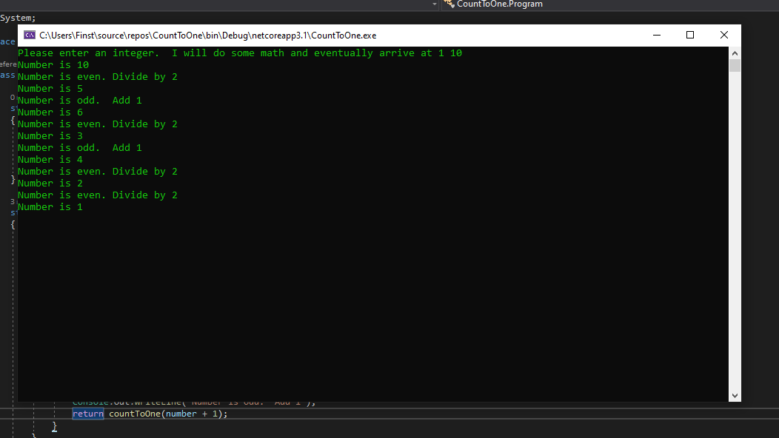

If the number is one, the program stops. If the number is even, it is divided by two and the result is evaluated. If the number is odd, one is added and the result is evaluated. This continues until the number is one.